Here Are Some Optical Illusions ( this is really cool )

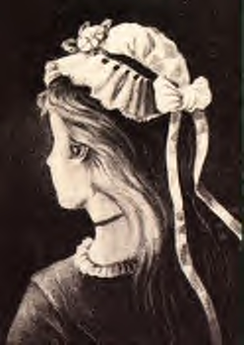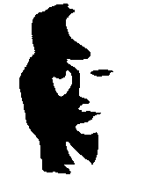
Old Woman...Or Young Girl?
hint: the old woman's nose is the young girl's nose and chin

Man Playing Horn... Or Woman Silhouette?
Hint: the handle of the horn is the woman’s nose
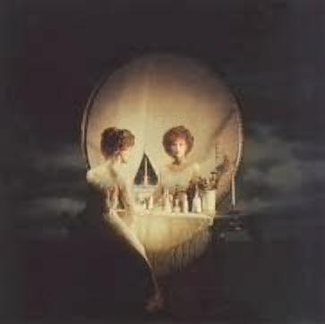
Woman In Vanity... Or Skull?
hint: move farther a bit from the screen and blink to see the skull or the woman (looking at the mirror)
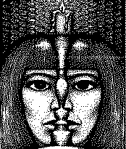
Two Faces... Or One?

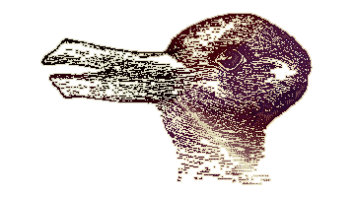
A Rabbit.... Or A Duck?
hint: the duck is looking left, the rabbit is looking right

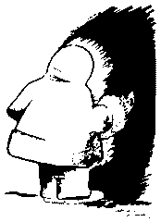
A Face Of A Native American... Or An Eskimo?


Is The Book Looking Towards You... Or Away From You?

NOW HERES THE DEAL. SEND THIS TO ATLEAST 6 PEOPLE AND A REALLY COOL OPTICAL ILLUSION WILL POP UP IN YOUR SCREEN IN THE NEXT 2 MINUTES. IM TELLING YOU IT IS WORTH IT.

